Matura paper

**turn that down!**

The Creation of a Synthesizer

Nikolaj Veljkovic

Supervised by

Sacha Di Piazza

Bern 2024



Gymnasium Kirchenfeld

Table of Contents

1 Introduction 3

2 Theory 4

2.1 Terminology 4

2.2 Components 4

2.2.1 Static and variable resistors 4

2.2.2 Capacitors 5

2.2.3 Inverting Schmitt trigger 6

2.2.4 NAND logic gate 6

2.2.5 Operational amplifier and buffer 6

2.3 Building blocks 8

2.3.1 VCO 8

2.3.2 VCF 8

2.3.3 VCA 9

2.3.4 LFO 10

2.4 Typical synth architecture 10

3 Process documentation 11

3.1 Tools 11

3.2 Prototyping 11

3.3 Soldering 16

3.4 Building the case and assembly 17

4 Critical analysis and improvements 20

5 Thanks 21

6 Appendix 22

6.1 cAdditional Images 22

6.2 References 22

7 Statutory declaration 25

# Introduction

I was inspired to write the following paper on the topic of analogue synthesizers[1] due to my fascination for technology and music. While searching for a topic I knew that I needed something that would make me engage and where I could put my energy into. Seeking a challenge, building a synthesizer seemed to be just right – combining my interests and allowing me to discover a domain of technology I had not been familiar with before. It would allow me to learn a lot about analogue electronics, as well as how synthesizers work. In this paper I will first explain what the main components of a synth are, as well as the hidden processes behind the creation of the sound. Then, I will explain how I planned and built a synthesizer myself. My goal is to deeply understand the inner workings of synthesizers while building my own. In my opinion, it is important that we understand the fundamentals of analogue electronics, as these topics get lost with the digitalisation of our world. To achieve this, I will first teach myself the electronic workings of a synthesizer, then build prototypes until I reach a desired outcome. As soon as I hold a working prototype in my hands, the next step will be soldering it onto a soldering board, making it compact. The last step will be putting the raw synthesizer into a nice case. My final goal is to hold a synthesizer in my hands that I have built and designed myself.

# Theory

To explain how a synthesizer functions, it is important to understand what individual components it consists of and how these components work together. I will use a water analogy to describe the influence of individual parts, as on a high level electrical current functions much like the flow of water. Further, I will use 12V while explaining certain mechanisms, but in every example the voltage could also be smaller or higher.

## Terminology

* Power supply: This is the source of the electricity flowing through the circuit. A battery or a wall socket are power supplies.
* Ground: Also abbreviated as GND. Name for the point where electricity flows out. In a circuit with a battery as the power supply the negative terminal is the ground [1].
* Voltage: For simplicity’s sake, voltage can be imagined as the amount of pressure in a water pipe. It gives us an understanding of how hard the electrons are being pushed through a circuit. Less voltage means also less water at a time being pushed through the pipe.

## Components

### Static and variable resistors

Current flowing through a circuit is similar to water flowing through a pipe (own drawing 1). In electronics, the wire is the pipe. When the water has no obstacle, it flows freely. Once a resistance, in the case of (own drawing 2) a narrowing of the pipe, is introduced, the amount of the water flowing through the pipe is decreased.

In synthesizers, the voltage is usually constant, for example 12V. This is the amount of pressure of the water going through a pipe. Therefore, a change in resistance changes the flow of the current, which in turn influences the pitch of the tone, as will later be explained.

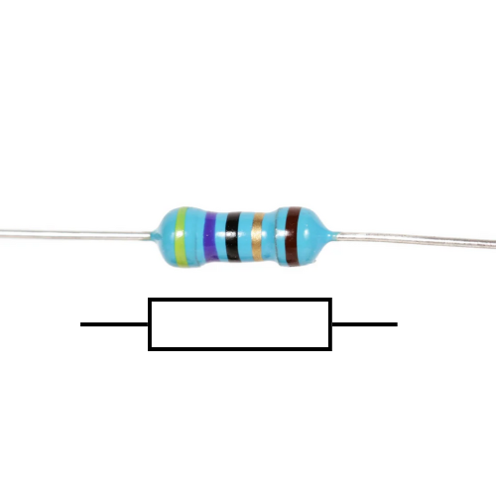

Figure ‑ : A five-band resistor and its circuit diagram symbol. randofo, Instructables: <https://www.instructables.com/Resistors/> [accessed and edited by Nikolaj Veljkovic 29 09 2024]

Figure 2‑1 shows a static resistor and its symbol. It usually has four to five coloured bands, which allow to identify the resistance of an individual resistor. These colour-codes can be read by using a resistor colour chart [Appendix 6‑1]. As opposed to other components, a resistor is apolar. This means it has no “right” direction. Inside the resistor there is a material that inhibits conductivity [2]. This material prevents the full current from passing through the resistor, decreasing the current in the circuit. It is the narrowing of the pipe.

A variable resistor has a different layout. It has three pins, a coil of resistive material and knob attached to a wiper, which is connected to the middle pin. By connecting an input voltage wire to an outer pin, and an output wire to the middle one, this will act as if a static resistor was between the two wires. Only that this resistance can be dynamically changed by turning the knob. As one can see in Figure 2‑3, the longer the connection of the input pin to the wiper head is, the more resistive coil is between the two, the greater the resistance. In a perfect potentiometer, the common name for variable resistor, the knob turned to the maximum corresponds to the maximal resistance. Vice versa, the knob to the minimum should yield no resistance. The maximal resistance is written on the top of the pot(entiometer).

A resistance is measured in Ohm Ω. When the values become big, they are written as kΩ (kiloohm – one thousand ohms) or even MΩ (megaohm – one million ohms).

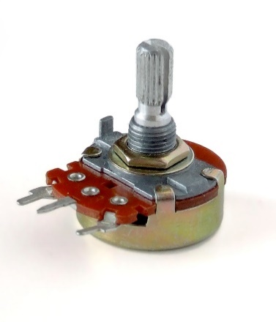

Figure ‑ : A potentiometer. Iainf, Wikipedia Commons: <https://commons.wikimedia.org/wiki/File:Potentiometer.jpg> [accessed 29 09 2024]

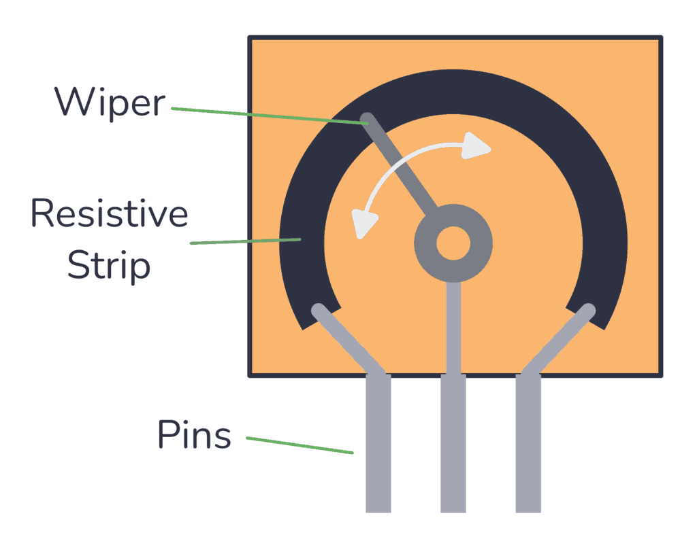

Figure ‑ : The inside of a variable resistor. Øyvind Nydal Dahl, buildelectroniccircuits: <https://www.build-electronic-circuits.com/potentiometer/> [accessed 29 09 2024]

### Capacitors

The capacitor in its function is similar to a water balloon (drawing balloon and pipe). When you place the water balloon at the end of a pipe, it fills up with water and stores it. At some point, when the balloon is full, it stops the water from flowing and starts pushing the water back into the pipe. The balloon is discharging [3, p. 7:35].

In an electronic circuit, the capacitor stores charge on one of two plates. As the electrons build up on one plate, the other plate has fewer electrons, because it discharged its electrons into the power supply. This creates a potential difference between the two plates, equal to the voltage of the power supply [4]. The more charge it stores, the more the resistance through the capacitor increases. This in turn prevents the current from flowing through the capacitor, effectively stopping the flow in the circuit. However, once the pressure of the current going into the capacitor drops below the capacitor’s own pressure level, the capacitor discharges.

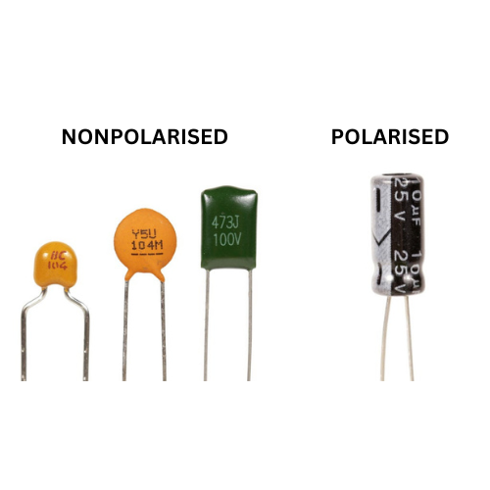

Figure ‑ : Different capacitors. unknown, Jak Electronics: <https://www.jakelectronics.com/blog/what-is-non-polarized-capacitor> [accessed and edited by Nikolaj Veljkovic 29 09 2024]

Figure 2‑4 shows multiple capacitors. A capacitor’s charging capacity, or capacitance, is measured in Farads [5]. In practice, this unit is much too big. Usually capacitors range from Microfarad (mF = 10-6 F) to Picofarad (mF = 10-12 F). In Figure 2‑4 one can see the capacitance denoted very clearly on the polarized capacitor (10mF). On the smaller, nonpolarized ones, it is harder to understand what their capacitance is exactly[2].

### Inverting Schmitt trigger

The following parts are not singular parts, but a combination of different components. They are called integrated circuits (IC) [6]. It is not in the scope of this matura paper to explain how integrated circuits work on a deeper level, as their function is much more important. Also, the following ICs only detect the voltage at the input and process that information. The current does not go directly through the circuit. There is an input for a supply voltage and ground connection. This is where the IC draws energy from, enabling it to output according to the calculated output signal.

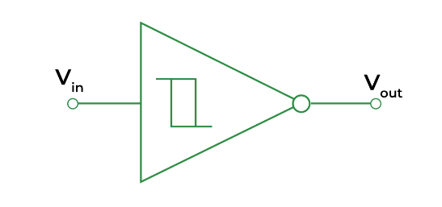A Schmitt trigger is a comparator. This means that it reads the analogue value at its input and compares it to its internal threshold. The exact threshold differs from IC to IC, but it is easiest to imagine it as right in the middle between maximal and minimal value[3]. If the value at the input is below this threshold, the output reads low. Has the input value surpassed the threshold, the output reads high. This is called hysteresis [7].

Figure ‑ : Inverting Schmitt trigger. unknown, GeeksForGeeks: <https://www.geeksforgeeks.org/schmitt-trigger/> [accessed 29 09 2024]

At the same time, the Schmitt trigger is also an analogue to digital converter. A digital signal is defined to be 1 or 0 (equivalent to high or low, on or off), whereas an analogue signal uses a continuous range of values [8]. The signal at the input is analogue, ranging from 0V to 12V, the output is digital, 12V or 0V.

The inverting Schmitt trigger does the same a Schmitt trigger does, only that it outputs the inverse of what a Schmitt trigger would. When the input is over the threshold and the Schmitt trigger would output high, the inverting Schmitt trigger outputs low. And the other way around.

### NAND logic gate

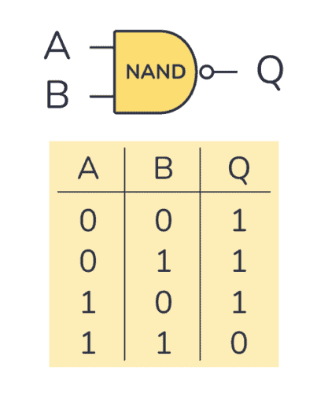

Figure ‑ : NAND gate and its truth table. Øyvind Nydal Dahl, buildelectroniccircuits: <https://www.build-electronic-circuits.com/nand-gate/> [accessed [29 09 2024]

This logic gate by itself is not an integrated circuit. In my use case however, it was. NAND is short for NOT AND. In an AND gate, the output is high when inputs one and two are high. The NOT signifies the inversion of that logic. In the logic table [Figure 2‑6] you can see what this means: The NAND gate always outputs high, except if both inputs are high. This gate also has a threshold to determine if the input is high or low.

### Operational amplifier and buffer

An op-amp, as it’s usually called, has two inputs. The first is called “inverting input”, marked with a minus, the second is the “non-inverting input”, marked with a plus [9]. It also has two power connections, the positive and negative voltage connections.

The op-amp amplifies the difference of its two inputs. It takes the voltage at the non-inverting input, e.g. 8V, and subtracts it by the voltage on the inverting input, e.g. 3V. The result gets amplified by a specific amplification factor called A, e.g. 100’000. The output will therefore be $5V*{100}^{'}000={500}^{'}000V$. As this is impossible, the op-amp outputs the maximum supply voltage, 12V.

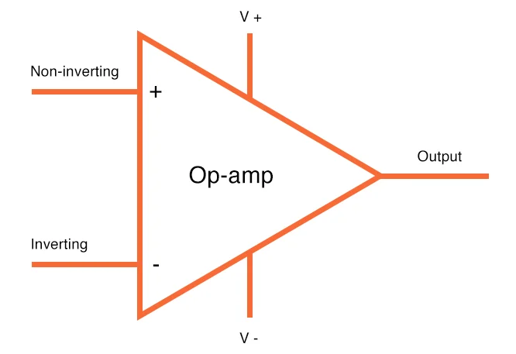

Figure ‑ : op-amp. unknown, All About Circuits: <https://www.allaboutcircuits.com/uploads/articles/op-amp-in-schematics.jpg> [accessed 29 09 2024]

The op-amp having its own power source brings great advantages with it, as it allows the output current to be very stable. An oscillator signal is often wavering[4] around instead of being stable, due to different parts acting unpredictably. Stabilisation of the signal is one of the main issues of sound technologies, which makes buffers a very important utility.

In a buffer [Figure 2‑8], there is a signal coming into the non-inverting input, for example 9V. The inverting input is connected to the buffers output. In the beginning, the output is zero, therefore, the inverting input is also zero. The subtraction equals 9V, so the op-amp will try to output 9V. As it does so, after a fraction of a second the output will be at e.g. 3V. This makes the difference smaller, but the gain with which it gets amplified is still large enough that the output rises. This will keep happening until the difference of the two inputs is extremely small. The output will then be approximately the same value as the non-inverting input. This is called a negative feedback loop [10]. Buffers are used in most audio processing technologies, because they reduce the unsteadiness of a signal.

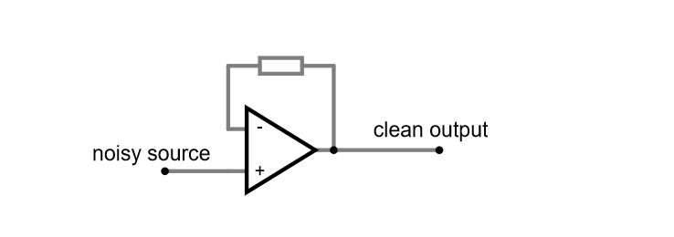

Figure ‑ : An op-amp buffer. Nikolaj Veljkovic, Falstad: <https://tinyurl.com/23cypsgv> [created 29 09 2024]

## Building blocks

### VCO

The “Voltage Controlled Oscillator” is the sound source of the instrument. The sound’s characteristics are defined by its wave. Depending on how many waves there are per second, the pitch either goes up or down. The shape of the wave makes the sound either smooth or noisy, loud or quiet, or anything in between.

The most common waveshapes are: Square, Triangle, Sine, and Sawtooth, as seen in Figure 2‑9. Different waveshapes produce different sounds. From left to right the sound gets harsher. While a sine wave could be compared to the sound produced by a flute, the square wave has a typical synth grit and harshness.

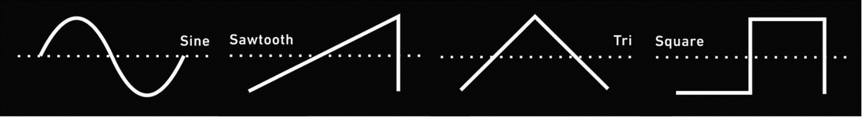

Figure ‑ : A comparison of four wave shapes. On the x-axis: time. On the y-axis: voltage. Length of the waveshape: one cycle. unknown, Pinterest, <https://www.pinterest.com/pin/1009087860241726171/> [accessed and edited by Nikolaj Veljkovic 18 08 2024]

An oscillator can be demonstrated with the circuit in Figure 2‑10. The two main components are the capacitor and the inverting Schmitt trigger. The oscillation starts with the capacitor assumingly discharged (around 0V). This leads the inverted Schmitt trigger to output high, charging the capacitor through the resistor. Once the capacitor is charged, the Schmitt trigger switches to low, because the voltage at its input is high. Now, the capacitor starts discharging through the resistor, and once it is discharged, one cycle of the oscillation is complete [11]. This is a very basic square wave oscillator. With the potentiometer it is possible to control how much of the current passes into the capacitor. The higher the resistance, the less current can flow, the slower the cap charges, the slower the oscillation, the lower the pitch. Resistance is therefore directly connected to the pitch and is used to control it.

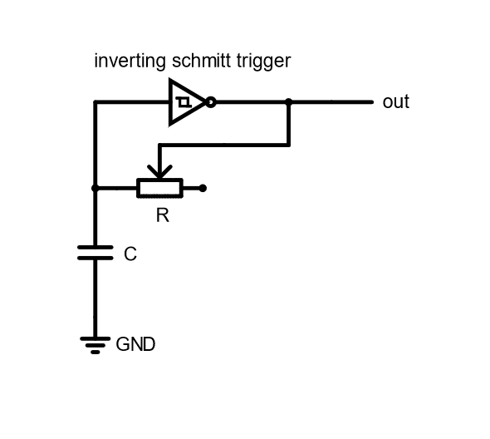

Figure ‑ : A simple square wave oscillator. Nikolaj Veljkovic, falstad.com: <https://tinyurl.com/29x8r54f> [created 18 08 2024]

### VCF

When one hears a tone, it is never just a pure tone. When the string of a guitar swings, there are tones ringing over the base tone. The overtones, as they are called, are certain intervals away from the base tone [12]. This effect is very common in nature, even our voices have overtones. When looking at a frequency spectrum [Figure 2‑11] of the middle g on the piano, multiple spikes are visible after that of the base tone. These spikes visualise the overtones.

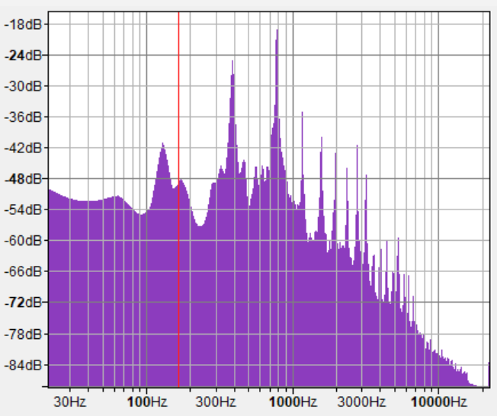As I mentioned in sub-chapter 2.3.1, depending on how many times a wave occurs in a second, the pitch changes. The number of waves per time is called frequency. Thus, the spikes in frequency are further pitches, or waves, swinging with the main wave, just at a faster rate.

Figure ‑ : A frequency analysis of the g note played on a piano. Nikolaj Veljkovic, Audacity [created 27 09 2024]

A “Voltage Controlled Filter” can cut off certain frequencies from the sound. Imagine a filter in a water pipe, sorting out all the dirt. The VCF can be configured in two ways: a low pass filter and a high pass filter respectively. As their name implies, the former cuts off all the high frequencies, where the latter cuts out all the low ones. A low pass filter [Figure 2‑12] consists of a resistor and a capacitor. If we recall our water analogy, the oscillation and the overtones can be seen as a sputtering of water through the pipe. The resistor controls how much water (current) can pass the pipe at once. Instead of letting the sputter continue to the output, the capacitor acts as a bucket which the water can dribble into. Once the bucket is full, the water can continue in a normal flow further to the output.

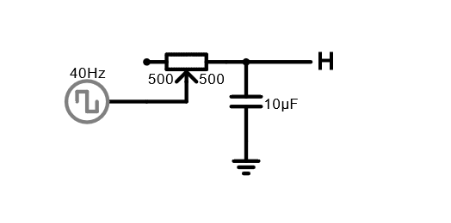

Figure ‑ : The circuit diagram of a low pass. Nikolaj Veljkovic, Falstad: <https://tinyurl.com/25qle9ds> [created 30 09 2024]

Those fast waves, our overtones, have thus been filtered out. By using a potentiometer, we can control how much water can pass through to the bucket. The less water passes, the more slowly the bucket fills up, the more frequencies are filtered out. Drain capacitor is the name for such a capacitor, as it drains the high frequencies into ground. For further information on how the wave shapes compare to one another, see Appendix 6‑2.

### VCA

After a VCO and VCF, a synthesizer produces sound whose pitch can be controlled. What cannot be controlled are the dynamics of that sound. The expression of the sound, alike to a violin player when they play a note quietly at first and get louder towards the end. It is not possible to play a note like pressing a piano, there is no control over the pauses in the sound.

The “Voltage Controlled Amplifier” gives the possibility of dynamics to the synthesizer. It reacts to the control voltage, CV for short. The CV can be a further oscillator, like a sine wave, or just a press of a button, resulting in a chain reaction. The VCA could try to imitate a piano, or grow louder and quieter, following the sine wave.

The shape of the sound can be described in accordance with the following characteristics: Attack, decay, sustain and release, also called ADSR. The ADSR envelope is a common way to describe how sound behaves over time [13]. The attack is how quickly after the beginning of the sound it reaches its peak. Decay determines how quickly it goes from the peak to a steady level. The steady level is you still holding the key, sustaining the sound. The loudness of that steady level is called sustain. Finally, the release tells us how quickly the sound goes quiet after the key has been released. In Figure 2‑13 the same note played on a violin and on a piano are compared.

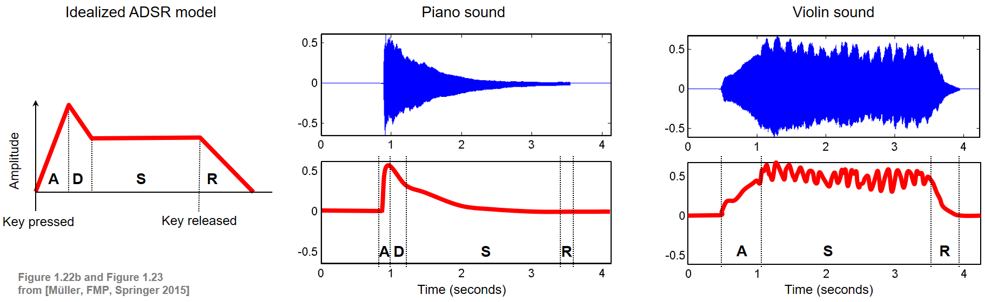

Figure ‑ : The same note played on a piano and a violin - a comparison of the ADSR envelopes. Meinard Müller, AudioLabs Erlangen: <https://www.audiolabs-erlangen.de/resources/MIR/FMP/C1/C1S3_Timbre.html> [accessed 27 09 2024]

### LFO

At its core, the “Low Frequency Oscillator” is nothing else than a slow VCO. While the VCO oscillates in ranges which we perceive as pitches, the LFO produces sounds which to us sound more like clicks.

LFOs are used to manipulate the modules mentioned in the previous sub-chapters. This process is called modulation. A LFO could, for example, be hooked up to a VCF, whose cut off point depends on the control voltage, provided by the LFO. When the CV input of the VCF is low, then almost the whole signal passes. When it’s in a higher range, more of the frequencies get cut off. Similarly, the so-called “wah-wah” effect used with guitars is nothing else than a modulation of the sound, only that guitarists do it with their own foot instead of an LFO [14].

## Typical synth architecture

Every synthesizer is different, yet many possess commonalities. The architecture of a synthesizer describes what modules (which were previously called building blocks) it is made of and in what order they are chained to each other. Usually, the first is the VCO. This makes sense: First, the sound has to exist before it can have something done to it. The VCF cuts off or adds certain frequencies. The LFO could be attached to any of the modules and modulate them individually. It could, for example, change the amount of cut off over time. Or it could influence the pitch. The VCA called [15].

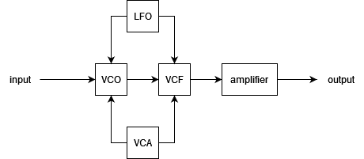

Figure ‑ : A typical synthesizer architecture. Nikolaj Veljkovic, <https://www.diagrams.net> [created 30 09 2024]

# Process documentation

## Tools

After I had some idea of what a synthesizer does, it was time to start prototyping. Thanks to Sacha Di Piazza, who is my mentor and supervisor, I did not have to buy any materials. He gave me all the parts I needed, as well as tools and a power supply.

In Figure 3‑1, one can see the tools I used while prototyping. The red box (1) is a digital oscilloscope. It displays the time on the x-axis and voltage level on the y-axis. The waveshapes in Figure 2‑9 are displayed using the same method. It was incredibly useful in helping me understand how the oscillator behaves when I tweak or exchange certain components. The metal frame (2) is used to combine different modules. I only used it as a power supply, as my supervisor built a special power supply (3) into it that could be directly stuck onto the breadboard. On the wooden board (4) there is the prototype of the synthesizer, wired onto a breadboard. The soldering iron (5) is what I used later when soldering the board together. Number 6 are pliers, which were extremely helpful when I had to cut wires or pull off the isolation from the wire. In the upper left part of the picture, one can see a reading lamp. I transformed my microphone boom arm into a highly adjustable desk lamp. This was very useful when working in the dark or having to see something very tiny.

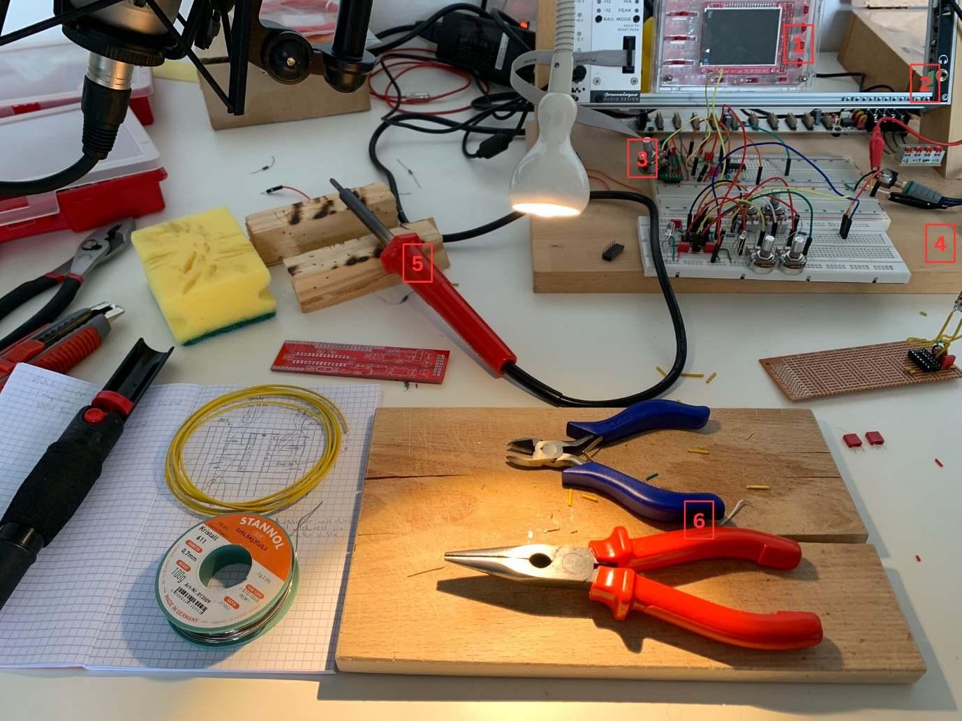

Figure ‑ : Tools I used while prototyping. Nikolaj Veljkovic [created 04 09 2024]

## Prototyping

Before I started building my synthesizer, I first had to know what a synthesizer is at its core. I had an idea of what synthesizers do, but I did not have the faintest idea how they did it. First, I read “Elektronik Basteln für Dummies” [16], which helped me understand some core elements of electronics. For the synthesizer logic, I read “Handmade Electronic Music” [17]. This phenomenal book opened my eyes to how simple some processes in the synthesizer actually are, and really motivated me to build one myself.

For every of the following circuits there is a circuit diagram in the appendix.

The breadboard is a board with holes in it under which wires pass. These wires are connected in a certain logic, such that it is easy to connect and combine different parts together, but also change and test combinations easily. The horizontal holes are linked together, this is where parts or ICs can be stuck into. The vertical holes (marked red and blue) are also interconnected and usually used for positive and ground supply. But in the power supply I used, the two upper power lines were +12V and +5V, and the two lower power lines were GND and -12V.

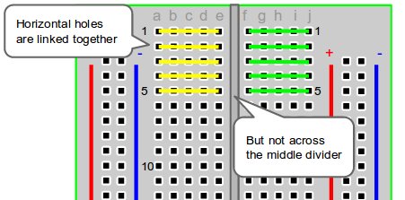

Figure ‑ : Breadboard wiring. Ben Miller, EnvatoTuts+: <https://computers.tutsplus.com/how-to-use-a-breadboard-and-build-a-led-circuit--mac-54746t> [accessed 02 10 2024]

The most basic oscillator is a square wave oscillator. Following a guide in “Handmade Electronic Music” [17, p. 116], it was surprisingly simple to build: The only parts required were a 10nF capacitor, a 100kΩ resistor and a HEF40106BP, which has six inverting Schmitt triggers. The joy I felt at the screaming sound out of my first VCO was incredible. One can see how this simple oscillator is configured in Figure 3‑3.

The problem with this design is that it is not very user friendly. It produces the same sound in the same pitch all the time. To change this, I substituted the normal resistor with a 100kΩ potentiometer. It can go from 100kΩ to 0Ω resistance. Because of this, I had to add a small pre-resistor of 1.2kΩ to prevent frying the circuit when the potentiometer let all the current pass. With a dynamically changeable resistance I could change the pitch of the sound as I wished. By changing around the value of the capacitor and resistor, I could choose the range I wanted my sound to be in. The low range pleased me a lot, so I chose a big resistor. But I still wanted to be able to have some squeaky sounds, so I had to have a small capacitor which could charge quickly. I chose a 100kΩ potentiometer and a 220mF capacitor.

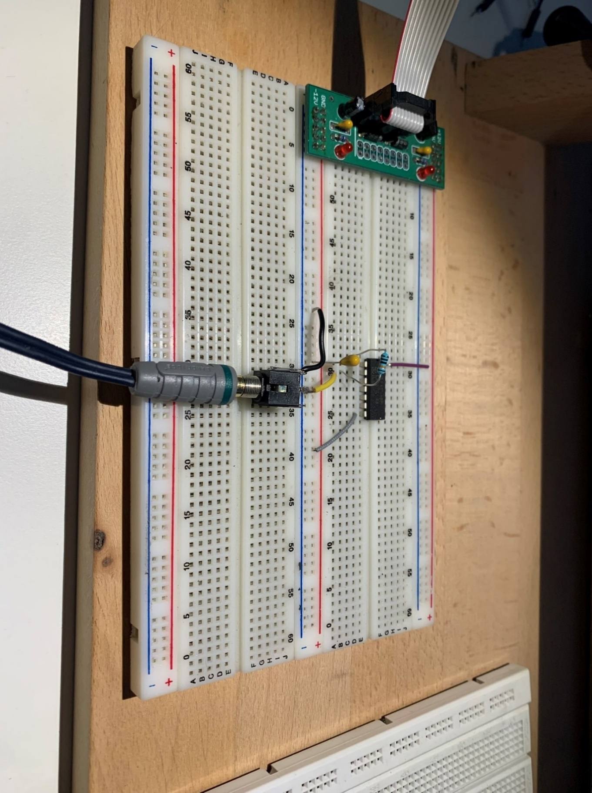

Figure ‑ : A simple square wave VCO. Nikolaj Veljkovic [created 11 06 2024]

Being satisfied with the result of one VCO, I added one more. And then, one more. Next, I started experimenting around with filters. In Figure 3‑4 one can see three similar VCOs. The two upper ones pass through a resistor before going into the jack output. I did this to see if it changed the stability of the sound in any way. As a matter of fact, it lowered the volume of those channels and removed some of the noise. The third VCO passes through a low-pass filter before going through the volume reducing resistor and then into the output.

Figure ‑ : Three VCOs. Nikolaj Veljkovic [created 04 07 2024]

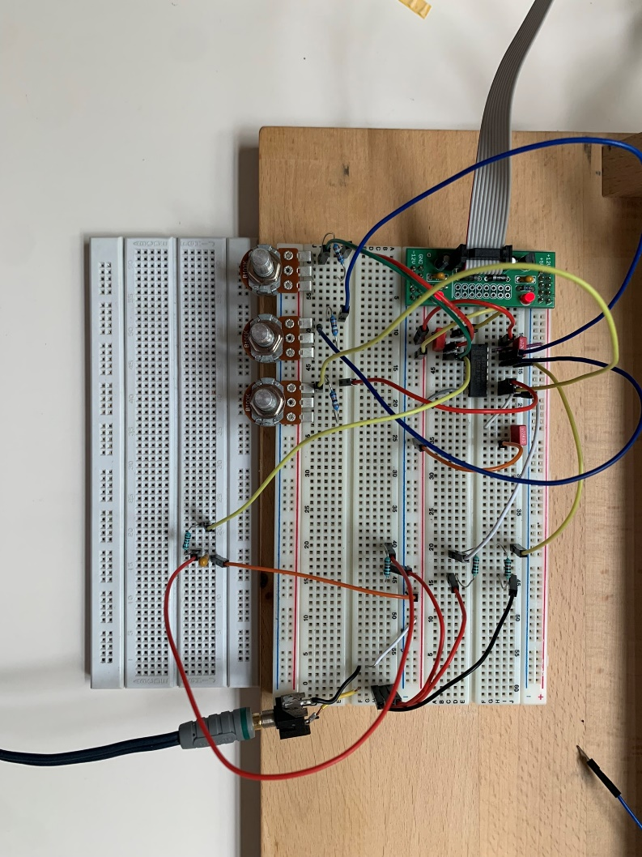

The low pass filter works as described in chapter 2.3.2. It has a 10nF drain capacitor and a 100kΩ resistor. This gave me a good idea of how far down I wanted to cut off the frequencies. It allowed me to play around with different sounds, but it wasn’t very dynamic. Therefore, I substituted the static resistor with a variable one, which now enabled me to cut off the high frequencies as I wished.

Next, I wanted to test a different kind of square wave oscillator, because I got inspired by a design [17, p. 132] in “Handmade Electronic Music”. The IC I used for it is the CD4011, and it consists of four NAND gates. I coupled two NAND gates together by taking the output of the first and connecting it to the input of the second. The input of the first NAND gate is a capacitor to ground and a 12V supply. One input of the second NAND gate is the first NAND’s output. The second input is a capacitor connected to ground. As the capacitor and the first input oscillate by themselves, this leads to interesting combinations of waves. I did the same with the remaining two gates in the IC. This way, I had two VCOs, each consisting of two coupled NAND gate oscillators [Figure 3‑5].

Figure ‑ : First NAND oscillator design. Nikolaj Veljkovic [created 04 07 2024]

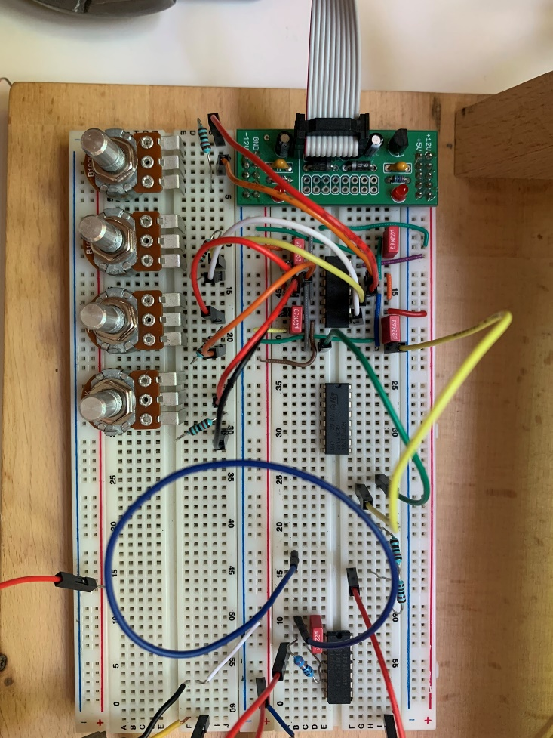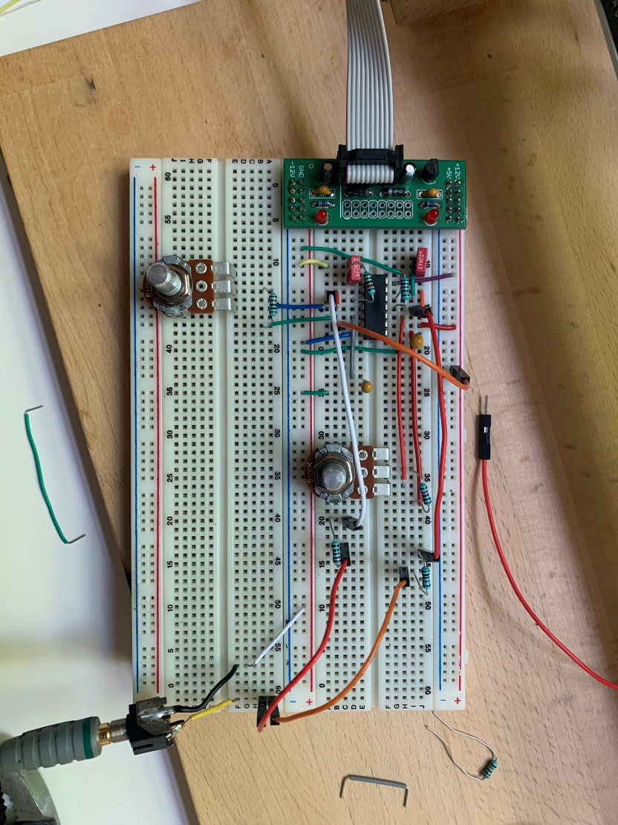

Figure ‑ : Second NAND oscillator design. Nikolaj Veljkovic [created 04 07 2024]

At first, I only put a potentiometer in the first oscillator of the VCO. My expectation when combining the two sources was to hear two separate oscillators, like a violin and flute playing together. Instead, it was one mixed sound. Turning one knob influenced the sound as a whole, even though the VCOs were only connected at the output.

To go even further, I replaced the static resistors in the second oscillator of the VCO again with potentiometers [Figure 3‑6]. I had the feeling that one VCO manipulated the other now even more. To test this, I attached the oscilloscope. What I found astounded me: They were influencing each other! When both VCOs were slow, the square wave was very wide. However, if one VCO was slow and the other fast, the fast one played only when the square wave of the first one was high. This phenomenon probably has to do with my circuit not being perfect. Somewhere the electricity might have been leaking into the other VCO, which made them influence each other. I did not mind this at all, though. I even liked the sound and, to some extent, the unpredictability of it. It also made the picture on the oscilloscope very captivating to look at.

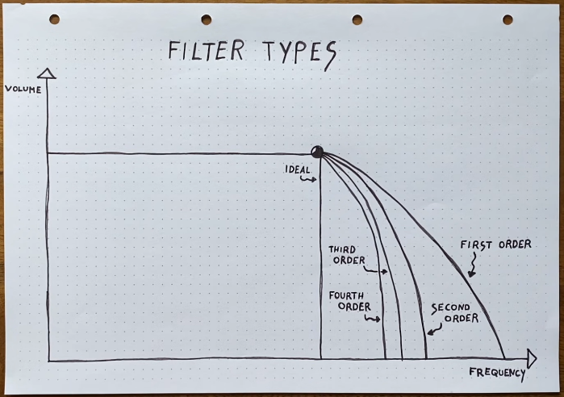Next, I played around with buffers. It is important to note that “playing around” was the main approach in this process. This in turn led to many prototypes not working properly. Either because of my lack of knowledge, or because of a mistake I did not notice. Therefore, there was a lot of trial and error involved in the process of building this synthesizer. I wanted to have a buffer before the signal went into an AC coupling and then a filter. Therefore, I used a NE5532AP chip with two op-amps in it. At first, I only had one buffer stage before a low pass filter. I wondered if anything had changed when there were two consecutive buffers. Maybe it would have, but in my case no signal passed. It could very well be that the IC was broken, as in the final model had working consecutive buffers. In Figure 3‑7 one can see what this prototype looked like.

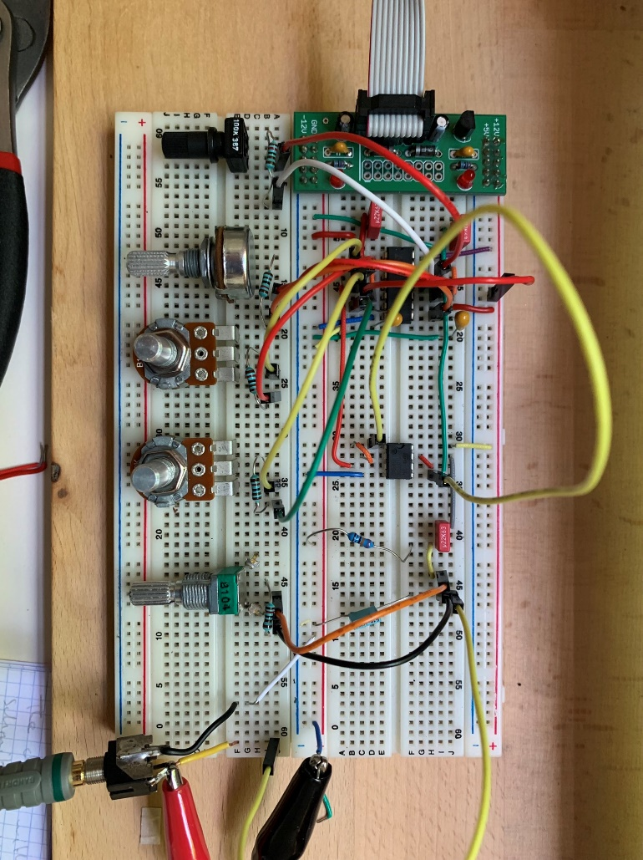

Figure ‑ : Double buffering into an AC coupling into a low pass filter. Nikolaj Veljkovic [created 04 07 2024]

Most of the process considering VCOs happened during the “Intensivwoche”. I had built a little office in a classroom, which kept me motivated, and I could sit and work there for hours. But starting from this next segment, I didn’t have the comfort of a dedicated workplace anymore. Instead, I set up a home office.

After having figured out what my sound source was supposed to be and sound like, I had to figure out the next step: filtering. A filter has a cutoff point, from where it starts to cut frequencies off. This cutoff point is not perfect, as it does not cut off all the frequencies from that point on. Instead, there is a long curve after the cutoff point, before the filter gets to a point where it actually cuts a whole frequency out. Two consecutive filter stages improve the cut off of the overall sound. The cut off efficiency of a filter can thus be categorised into so called “orders” [placeholder -Figure 3‑8]. One filter stage is a “filter of the first order”. Two filter stages are a “filter of the second order”, and so on. It is practically impossible to have a perfect filter, only getting very close to the ideal cut off point is possible.

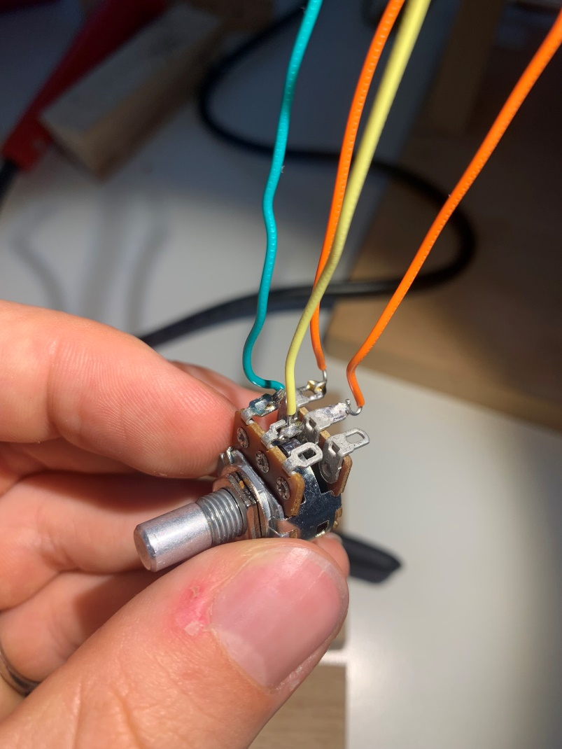

Figure ‑ : A stereo potentiometer. Nikolaj Veljkovic [created 21 08 2024]

Figure ‑ : Orders of filter stages. Moritz Klein, youtube.com: <https://www.youtube.com/watch?v=3tMGNI--ofU&list=PLHeL0JWdJLvT1PAqW4TtvxtRoXyk741WM> [accessed 30 09 2024]

Having this in mind, I decided to make a second order filter. For this to work out, I needed two consecutive filter stages, which was the easy part. The difficult part was turning both potentiometers at the same time, as this is what makes it actually work. There is no use in a double filter when one does not filter at all. Luckily, stereo potentiometers exist. They are a 2-in-1 miracle, one knob controlling two potentiometers. In Figure 3‑9: one can see what it looked like after I soldered wires onto it (I later added the two missing ones). Using this, I was able to control both filter stages simultaneously, and the difference was enormous. The filter now cut off much more of the frequency and it was a cleaner sound.

However, a new issue came up: The more the filter cut off the frequency, the quieter the signal became. This is because the second filter stage only gets some of the signal after the first filter stage. There is nothing separating the two and therefore current only “leaks” through to the second filter stage. Here, a buffer comes in handy. It can separate the two stages but still provide the same signal [10]. I thus added one buffer after the first and one after the second filtering stage [Figure 3‑10]. With that, I had a VCO and VCF ready to go. It was time to get soldering.

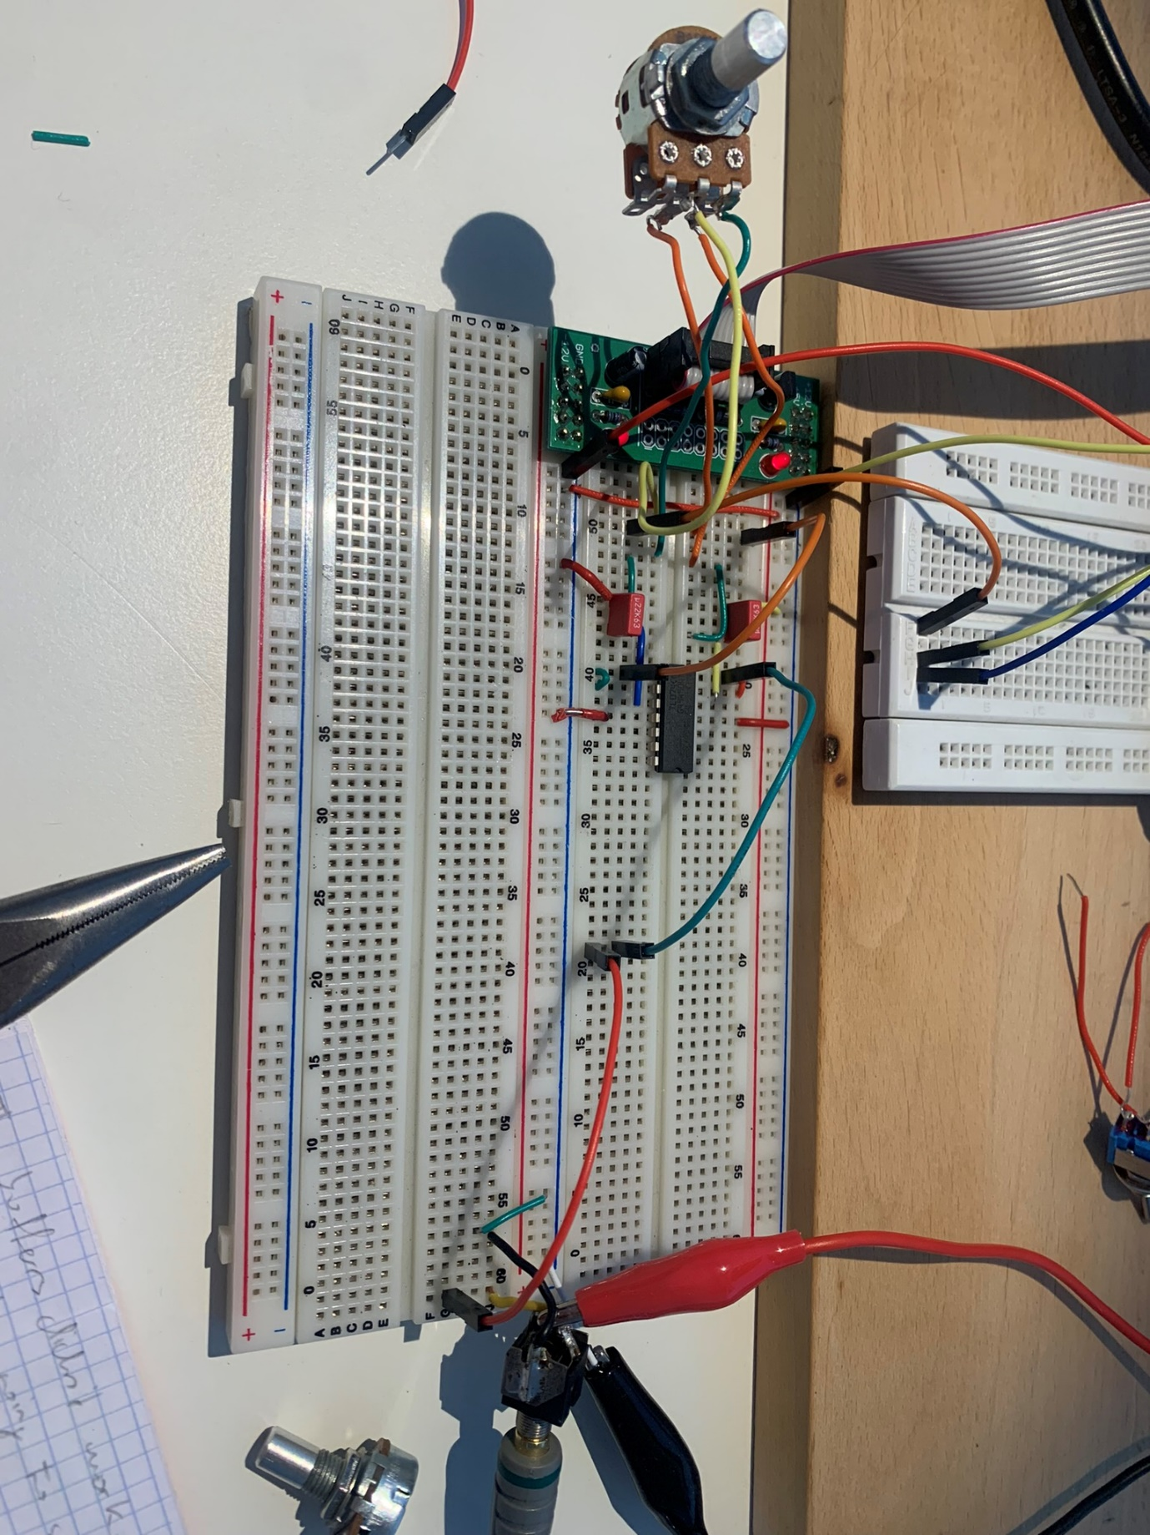

Figure ‑ : Filter-buffer-filter-buffer and a stereo potentiometer. Nikolaj Veljkovic [created 23 08 2024]

## Soldering

While a breadboard is useful in prototyping, it is not very handy. Due to its size, it cannot be put in a case or into small appliances, like a phone. That’s why soldering boards exist. They come in varying shapes and sizes, can be custom printed and are much more specific compared to a breadboard. Due to their compact nature, all electrical use soldering boards for their hardware. On the backside of a soldering board run copper coatings. These are like the connections on a breadboard: When two parts are soldered onto the same strip of copper, they are connected.

This was the first time since the 7th grade that I soldered again. At first difficult to get into, I quickly got a good idea of what I needed to do. Going from breadboard to a soldering board was much trickier than I had initially thought. There were many more pieces that had to be crammed into a tight space. Because of that I spent a lot of time planning the layout [figure notebook].

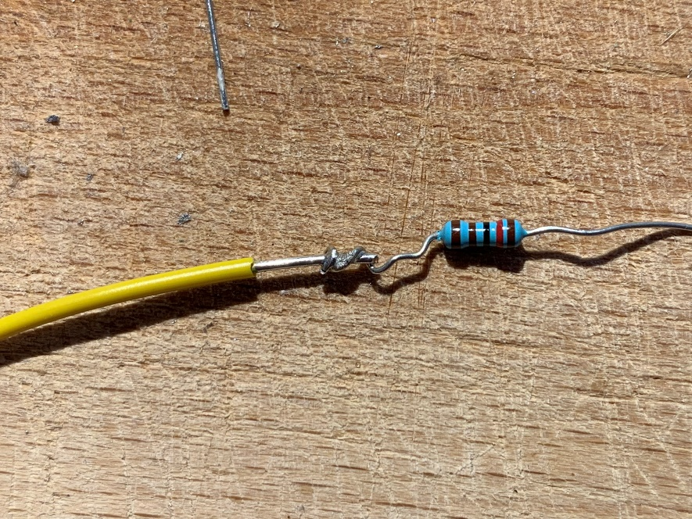

Figure ‑ : A resistor soldered to a wire. Nikolaj Veljkovic [created 04 09 2024]

At first, I soldered wires onto the potentiometers. As mentioned in chapter 3.2, a potentiometer has to be accompanied by a pre-resistor, so that the circuited does not get shorted when the potentiometer is at 0 resistance. Because of space limitations, I soldered the resistor directly to the wire connected to one of the legs of the pot [Figure 3‑11].

The first thing I soldered onto the board was an IC socket. As the name says, it can hold an IC and is used for easier replacement in case of a malfunction. After, I soldered the capacitors and wires. The potentiometers came last, as they have wires which could be fit into a tight space, when all the other parts were already soldered.

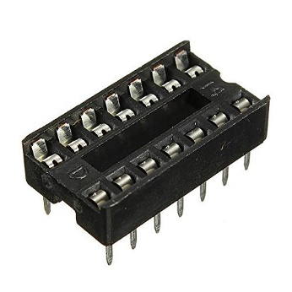

Figure ‑ : An IC socket. unknown, Amazon: link [accessed 30 09 2024]

By no means did the soldering go smoothly. Several times I soldered something into the wrong hole, soldered two holes together that were not supposed to touch, burnt some copper off the back side of the board and even burnt myself once. To some extent, these mistakes happened due to my lack of concentration, but some were also because of bad equipment. I am not very proud of my soldering, but it did the job. In Figure 3‑13 one can see the Battlefield of Solder.

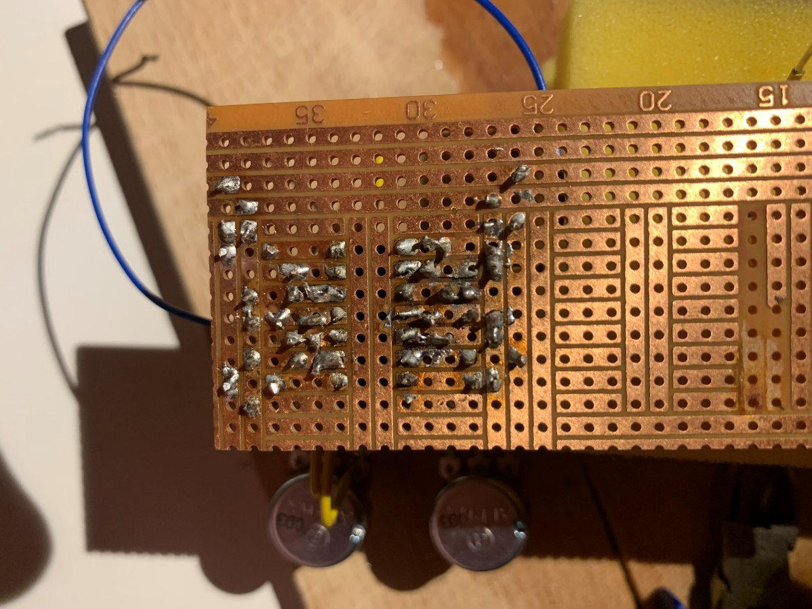

Figure ‑ : Back side of the VCO module. Nikolaj Veljkovic [created 06 09 2024]

I had intentionally cut too long wires for the potentiometers. Because of this they look all wrinkly and weird. Them being too long allowed me to turn them in any direction, allowing for more flexibility. Next, I added wires for the audio output and two cables for the power supply. To remember which cable was ground, I marked it with black isolation tape. I hooked up the VCO to a power supply and the cables with my amplifier. It worked! The sound was not exactly the same as on the breadboard, but it responded similarly to the input. After having successfully completed the VCO it was time to solder the VCF.

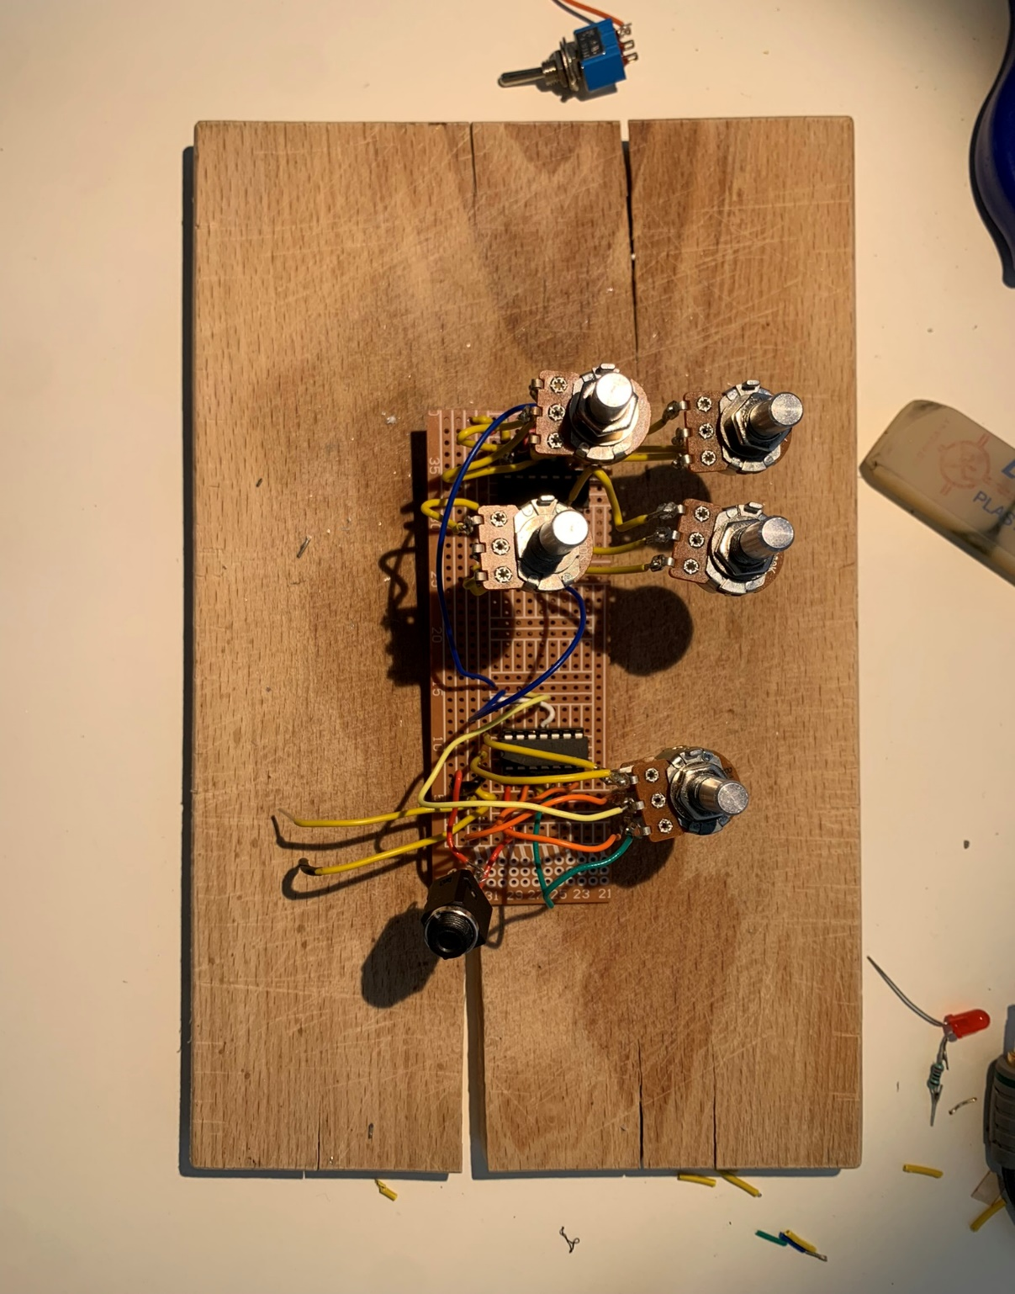

Figure ‑ : The finished circuit board. Nikolaj Veljkovic [created 13 09 2024]

Soldering the VCF turned out a little complicated. Some of the copper was missing in the planned space, so I had to be creative and wire it a bit uglier than planned. The major challenge, however, was soldering the stereo potentiometer. Keeping the wires in their holes while the board was on its head was quite tricky. But after some pushing and stabilising, I managed to solder it in. After connecting the audio wires from the VCO to the input of the first filtering stage and adding an audio jack, I tested the circuit. It worked! Although it did cut out sometimes, it worked. I did not think it would after having rewired and de-soldered it so often.

## Building the case and assembly

For the case, I knew from the beginning that it should be in a box. I liked the idea of having a somewhat “rough-looking” synthesizer, on which I could put my own handwriting. For a long time, however, I could not find anything that pleased my imagination exactly. Therefore, I chose an old perfume box my mother had lying around.

In Figure 3‑15 there is the rough drawing of the layout I wanted. Before, I planned it in my notebook (maybe appendix scan?). I put the potentiometer with the knob on the top of the box and drew a rough circle where it should pass through. The plan was to drill a hole and then stick the knob of the potentiometer through from below. I did the same process for the other four as well. Then, I drilled the holes on my balcony, as this is the closest I have to a work bench at home [Figure 3‑16]. Before putting the potentiometers through the holes, I wanted to colour the lid.

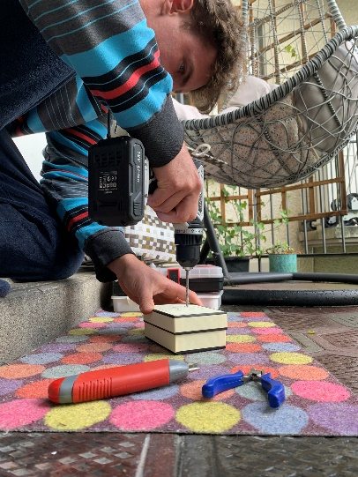

Figure ‑ : Drilling holes. Nikolaj Veljkovic [created 13 09 2024]



Figure ‑ : Rough sketch. Nikolaj Veljkovic [created 13 09 2024]

The colouring was quite simple, but time consuming. It was not possible to colour onto the box directly, as the print would not allow for it to be even. Thus, I taped it with yellow tape [Figure 3‑17]. This gave the synthesizer its weird, uneven look. With the support of my mother, saving time and bonding simultaneously, the case was coloured with a dark blue marker.

The potentiometers I used have a nut screw, which can be taken off. They also have a small bit of metal standing out, assumingly used to fix the potentiometer in its position. I could not use that, and it made the positioning of the potentiometer quite difficult. So, I broke it off [Figure 3‑18]. After putting the knob of the potentiometer through the hole, I screwed it tight with the nut screw I had taken off before. A mistake I made while drawing the design was that I did not account for the size of the body of the potentiometer. This led to me having to squeeze them together and even put a sheet of isolation tape in between, because the metal was touching.

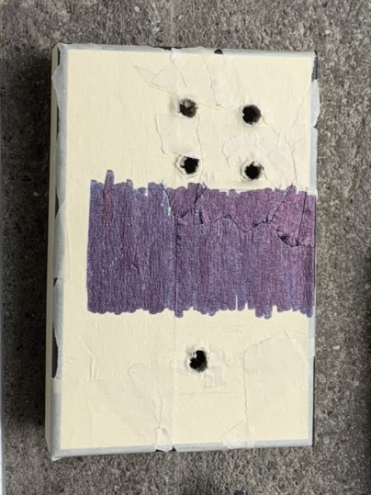

Figure ‑ : Colouring the lid. Nikolaj Veljkovic [created 13 09 2024]

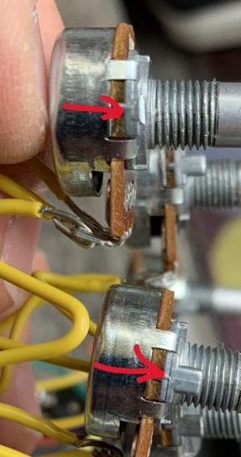

Figure ‑ : The unnecessary metal part. Nikolaj Veljkovic [created 13 09 2024]

Up to that point, I had not drilled the holes for the audio output and the power supply. I did not know where they would exactly be after I put the potentiometers in the cover of the box. After screwing the potentiometers into the lid, I could draw in the position of the audio jack and power supply [Figure 3‑19].

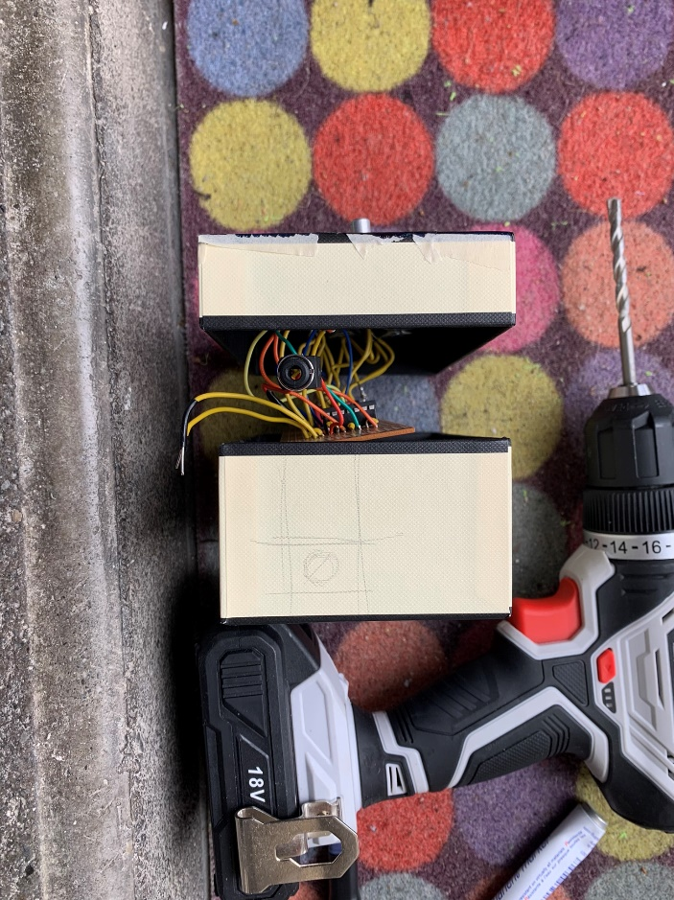

Figure ‑ : Planning the location of the audio jack hole. Nikolaj Veljkovic [created 13 09 2024]

To colour the body of the box I used the same process as with the lid. The most difficult of all I had done up to now was getting the audio jack through the hole. It was impossible for me to pull it through the hole without putting the lid on, which in turn meant I could not move the audio jack. I solved it by threading a thin audio cable through the hole and sticking it into the jack input. When the box was closed, I had to pull extremely slowly, to not yank the cable out. After several tries, the help of my mother’s thin fingers and cries of frustration, we managed to push it through the hole. I stabilised it with a nut screw, similar to the potentiometers.

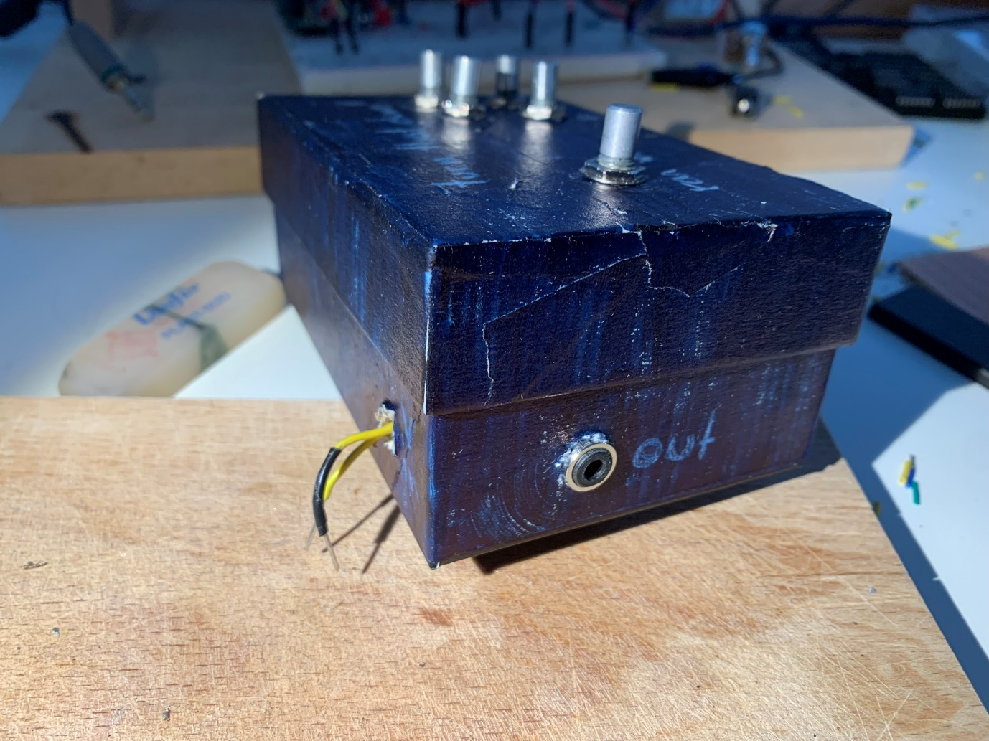

Figure ‑ : The two side-holes. Nikolaj Veljkovic [created 13 09 2024]

For the power supply I wanted to make two thin holes. Unfortunately, I pushed a little too hard while drilling, which made a bigger hole than required. I decided to put both power wires through one hole. One can see what it looked like in the end in Figure 3‑20.

Satisfied with the look of the synthesizer, I decided to test it. I attached the two wires to the 12V power supply and hooked up a speaker to the audio jack. Immediately after turning on the power, the synth came to life. However, I quickly realised that something was wrong.

The VCO knobs did not react as they did in the previous test. And instead of the filter cutting of frequencies, it randomly either turned the whole sound of, or modulated the pitch. I was very unhappy, but due to my tight schedule I could not go back and fix the issue. Luckily, I had not labelled the synthesizer yet.

I had been playing around with names for a while, but “turn that down!” was the one that I liked the most. It was what my mother told me after hearing the sound of it for the first time. Using a white crayon, I wrote the name on the top of the synth. I intentionally wrote it very weirdly to match the already rugged appearance and the weird sounds. The knob which was once a filter got named “random”, and the VCOs became “pitch”. I also wrote “out” next to output jack and “V in” next to the power supply cables. The latter does not make much sense, it would have been better to simply write “power” or just “V”.

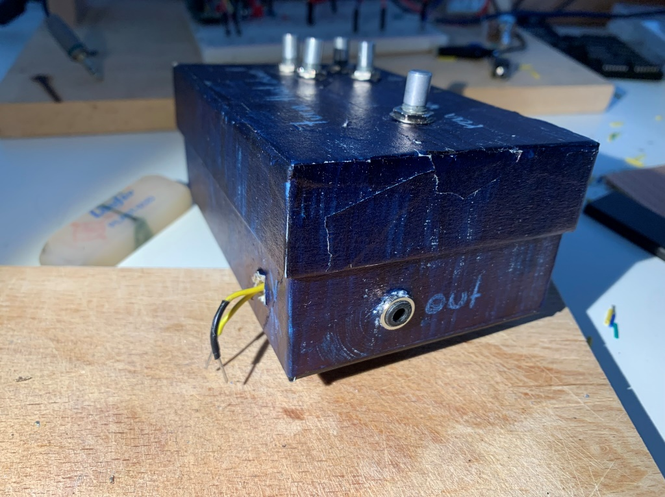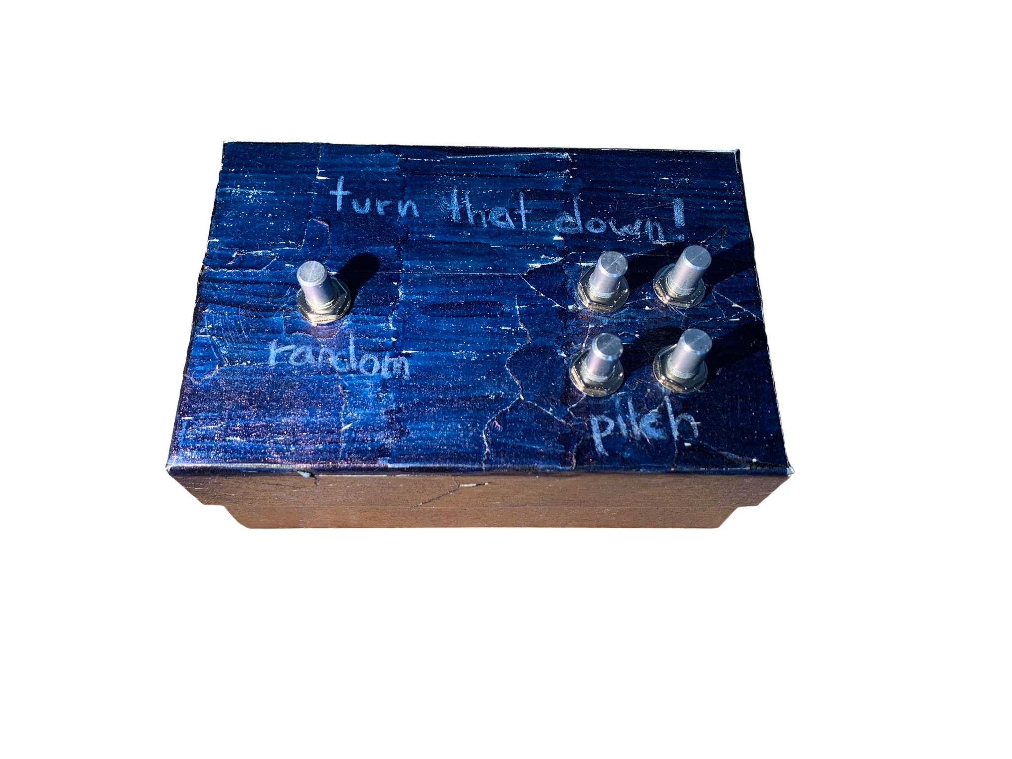

Figure ‑ (top), Figure ‑ (bottom): The finished synthesizer. Nikolaj Veljkovic [created 13 09 2024]

# Critical analysis and improvements

I enjoyed working on the synthesizer a lot and it sparked my interest for electronical engineering. However, there are many things that I could have improved in.

To start off: motivation and focus. It was often hard for me to start working. Even though I could get lost in the work, pushing myself to start was very difficult. For my next paper I will have to implement a system which makes it easier for me to work. While writing the paper, I used the pomodoro method, which proved to be very effective in my workflow. Taking a five-minute break every 25 minutes gave my brain the possibility to catch some air and allowed me to focus on the task again. More often than not, I realised something during a break that I would not have otherwise. Transferring my “office” to school also helped out a lot, as the different environment helped me focus much more on the task ahead.

During prototyping I should have kept a more rigorous journal of my work. It would have helped me after a longer break when I forgot what I had done in the past work session. On a positive note, I usually summarised the different functions of ICs in a notebook. This meant I did not have to go and search for that information over and over again in the datasheet but could just open up my notes.

All these things wasted time and led to me only having a two-module synthesizer. In my next prototype I would like to have an LFO and a batter as the power supply.

# Acknowledgments

Yet to come.

# Appendix

## Additional Images

Appendix ‑: From left to right – Clean square wave, low-passed square wave and high-passed square wave. Nikolaj Veljkovic, Falstad: <https://tinyurl.com/2985fpd9> [created 30 09 2024]

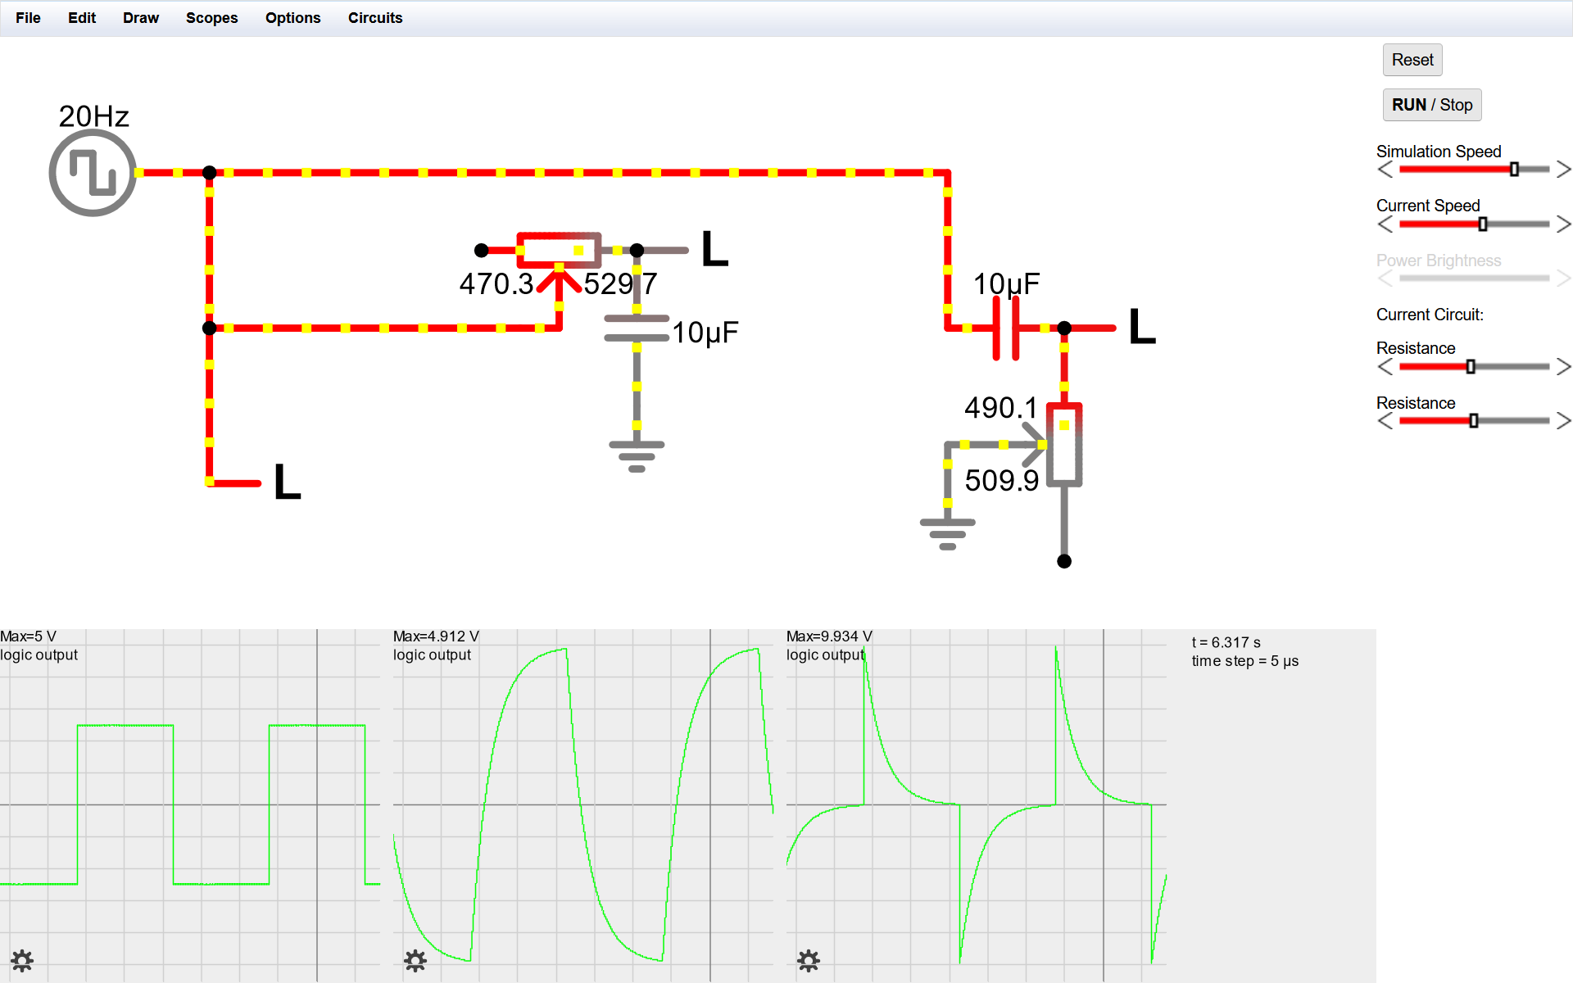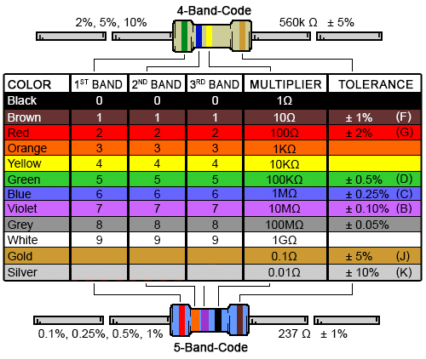

Appendix ‑: A resistor colour chart. unknown, DigiKey: <https://www.digikey.com/-/media/Images/Marketing/Resources/Calculator/resistor-color-chart.png?la=en-US&ts=4db603f5-4e9b-4759-84b7-21a04d18b1a8> [accessed 29 09 2024]

## References

|  |  |
| --- | --- |
| [1] | Ø. N. Dahl, “What is Ground in Electronic Circuits?,” buildelectroniccircuits, 18 09 2020. [Online]. Available: https://www.build-electronic-circuits.com/what-is-ground/. [Accessed 27 09 2024]. |
| [2] | EETech Group, “EEPower,” [Online]. Available: https://eepower.com/resistor-guide/resistor-materials/. [Accessed 24 06 2024]. |
| [3] | M. Klein, “DIY SYNTH VCF Part 1: Analog Filtering Basics,” Moritz Klein on YouTube, 15 12 2020. [Online]. Available: https://www.youtube.com/watch?v=3tMGNI--ofU. [Accessed 03 07 2024]. |
| [4] | University of Birmingham, “Physics A level revision resource: Introduction to capacitors,” University of Birmingham, 2024. [Online]. Available: https://www.birmingham.ac.uk/study/undergraduate/schools-and-colleges/post-16/a-level-stem-resources/capacitors. [Accessed 03 07 2024]. |
| [5] | P. Ravarini, “Farad,” Pravarini, 2024. [Online]. Available: http://pravarini.free.fr/Farad.htm. [Accessed 26 09 2024]. |
| [6] | Britannica, “integrated circuit,” Britannica, 24 06 2024. [Online]. Available: https://www.britannica.com/technology/integrated-circuit. [Accessed 26 09 2024]. |
| [7] | Wikipedia, “Schmitt trigger,” Wikipedia, 21 09 2024. [Online]. Available: https://en.wikipedia.org/wiki/Schmitt_trigger. [Accessed 2024 09 25]. |
| [8] | Tutoroot, “What are Analog and Digital Signals?,” Tutoroot, 01 05 2023. [Online]. Available: https://www.tutoroot.com/blog/what-are-analog-and-digital-signals-definition-difference-examples/. [Accessed 25 09 2024]. |
| [9] | Toshiba, “What is an op-amp?,” Toshiba, 2024. [Online]. Available: https://toshiba.semicon-storage.com/ap-en/semiconductor/knowledge/faq/linear_opamp/what-is-an-operational-amplifier.html. [Accessed 26 09 2024]. |
| [10] | M. Klein, “DIY SYNTH VCF Part 2: Active Filters & Resonance,” Moritz Klein on YouTube, 04 01 2021. [Online]. Available: https://www.youtube.com/watch?v=YNoj9Rrw_VM. [Accessed 26 09 2024]. |
| [11] | E. Corpeño, “Exactly How Schmitt Trigger Oscillators Work,” All About Circuits, 23 05 2018. [Online]. Available: https://www.allaboutcircuits.com/technical-articles/exactly-how-schmitt-trigger-oscillators-work/. [Accessed 28 09 2024]. |
| [12] | R. E. Berg, “Overtones,” Britannica, 13 09 2024. [Online]. Available: https://www.britannica.com/science/sound-physics/Overtones#ref-14249. [Accessed 28 09 2024]. |
| [13] | M. Müller and T. Zunner, “Timbre,” AudioLabs Erlangen, 2015. [Online]. Available: https://www.audiolabs-erlangen.de/resources/MIR/FMP/C1/C1S3_Timbre.html. [Accessed 28 09 2024]. |
| [14] | 3D Varius, “History of the wah,” 3D Varius, 22 04 2022. [Online]. Available: https://www.3d-varius.com/history-of-the-wah/. [Accessed 28 09 2024]. |
| [15] | D. Solaris, “Synthesizer basics,” Don Solaris Sound Design, 18 03 2014. [Online]. Available: https://www.donsolaris.com/?p=493. [Accessed 29 09 2024]. |
| [16] | G. Weichhaus, Elektronik Basteln für Dummies, Wiley-Vch, 2020. |
| [17] | N. Collins, Handmade Electronic Music: The Art of Hardware Hacking, 2nd ed., Routledge, 2009. |
| [18] | S. B, “Electronics StackExchange,” 05 04 2021. [Online]. Available: https://electronics.stackexchange.com/a/558607. [Accessed 09 06 2024]. |
| [19] | crashdmj, “Reddit r/FastLED,” 2022. [Online]. Available: https://www.reddit.com/r/FastLED/comments/va6u1p/hardware_question_for_sound_reactive_35mm_jack/. [Accessed 09 06 2024]. |
| [20] | S. J. Battle, “LOOK MUM NO COMPUTER,” 16 10 2017. [Online]. Available: https://www.lookmumnocomputer.com/projects/#/simplest-oscillator. [Accessed 09 06 2024]. |
| [21] | BBC Authors, “BBC Bitesize,” 2024. [Online]. Available: https://www.bbc.co.uk/bitesize/guides/z48gmfr/revision/2. [Accessed 24 06 2024]. |
| [22] | R. L. Taylor, “Electron Current vs. Conventional Current,” 21 09 2017. [Online]. Available: https://web.engr.oregonstate.edu/~traylor/ece112/lectures/elect_flow_vs_conv_I.pdf. [Accessed 24 06 2024]. |
| [23] | R. Wilson, “MFOS Ten Step Analog Sequencer,” Music From Outer Space, 10 06 2010. [Online]. Available: https://musicfromouterspace.com/analogsynth_new/TENSTEPSEQUENCER/TENSTEPSEQUENCER.php. [Accessed 05 07 2024]. |

# Statutory declaration

Hereby I confirm that I have written the present matura paper by myself and in the process have used no other than the mentioned sources. The literal or contextual copying of content has been marked as such by according citations. When translating certain words I used Google Translate.

Nikolaj Veljkovic

Bern, 18. Oktober 2024

Signature:

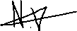

1. Throughout this paper I will use the standardised American spelling of the instrument.
2. For further information, go to: <https://www.wikihow.com/Read-a-Capacitor>
3. For the exact explanation, go to: <https://www.ti.com/lit/ab/scea046a/scea046a.pdf?ts=1727485822924>
4. The «wavering» is called noise.